 | Mahavir Education Trust's  SHAH & ANCHOR KUTCHHI ENGINEERING COLLEGE  Chembur, Mumbai - 400 088  UG Program in Computer Engineering

Major Project – I Report
2022-2023
Project Report on

Hyperspectral Image Classification using Few shot learning based on prototypical network

Submitted in partial fulfillment of the requirements
of the degree of Bachelor in Engineering

by

Name of the Student | Class | Roll No.
Adit Chheda | BE-4 | 07
Mayank Kantharia | BE-4 | 25
Aditya Shah | BE-4 | 58
Shivam Jadhao | BE-9 | 29

Under the guidance of
Dr. Manimala Mahato



DEPARTMENT OF COMPUTER ENGINEERING
SHAH AND ANCHOR KUTCHHI ENGINEERING COLLEGE
CHEMBUR, MUMBAI – 400088.
2022 – 2023

Certificate

This is to certify that the report of the project entitled

Hyperspectral Image Classification using Few shot learning based on prototypical network

is a bonafide work of
Name of the Student | Class | Roll No.
Adit Chheda | BE-4 | 07
Mayank Kantharia | BE-4 | 25
Aditya Shah | BE-4 | 58
Shivam Jadhao | BE-9 | 29
submitted to the
UNIVERSITY OF MUMBAI
during semester VII in partial fulfillment of the requirement for the award of the degree of
BACHELOR OF ENGINEERING
in
COMPUTER ENGINEERING.

---------------------------------------
(Dr. Manimala Mahato)
Guide

------------------------------------------ | ---------------------------------------
(Prof. UdayBhave) | (Dr. Bhavesh Patel)
I/c Head of Department | Principal

Approval for Project Report for B. E. Semester VII

This project report entitled Hyperspectral Image Classification using Few shot learning based on prototypical network by Adit Chheda, Mayank Kantharia, Aditya Shah, and Shivam Jadhao approved for semester VII in partial fulfillment of the requirement for the award of the degree of Bachelor of Engineering.

Examiners
1.__________________________
2.__________________________
Guide
1.__________________________
2.__________________________

Date:
Place:

Declaration
We declare that this written submission represents our ideas in our own words and where others' ideas or words have been included, we have adequately cited and referenced the original sources. We also declare that we have adhered to all principles of academic honesty and integrity and have not misrepresented or fabricated or falsified any idea/data/fact/source in our submission. We understand that any violation of the above will be cause for disciplinary action by the Institute and can also evoke penal action from the sources which have thus not been properly cited or from whom proper permission has not been taken when needed.

Name of the Student | Class | Roll No. | Signature
Adit Chheda | BE-4 | 07 | 
Mayank Kantharia | BE-4 | 25 | 
Aditya Shah | BE-4 | 58 | 
Shivam Jadhao | BE-9 | 29 | 

Date:
Place:

Attendance Certificate

Date
To,
The Principal
Shah and Anchor Kutchhi Engineering College,
Chembur, Mumbai-88

Subject: Confirmation of Attendance
Respected Sir,

This is to certify that Final year (BE) students Adit Chheda, Mayank Kantharia, Aditya Shah, and Shivam Jadhao have duly attended the sessions on the day allotted to them during the period from 18/07/2022 to 29/10/2022 for performing the Project titled Hyperspectral Image Classification using Few shot learning based on prototypical network.

They were punctual and regular in their attendance. Following is the detailed record of the student’s attendance.

Attendance Record:

Date | Adit Chheda | Mayank Kantharia | Aditya Shah | Shivam Jadhao
 | Present/Absent | Present/Absent | Present/Absent | Present/Absent
18/07/2022 | Present | Present | Present | Present
25/07/2022 | Present | Present | Present | Present
01/08/2022 | Present | Present | Present | Present
22/08/2022 | Present | Present | Present | Present
29/08/2022 | Present | Present | Present | Present
05/09/2022 | Present | Present | Present | Present
19/09/2022 | Present | Present | Present | Present
26/09/2022 | Present | Present | Present | Present
03/10/2022 | Present | Present | Present | Present
29/10/2022 | Present | Present | Present | Present

Signature and Name of Internal Guide
Abstract
The issue of few-shot picture categorization when it comes to hyperspectral remote sensing images (HSIs) is a common problem faced when working with HSI images. The few-shot classification algorithms are quite prominent in remote sensing generally because it is challenging to gather a large number of labeled training examples. The fact that the model is likely to overfit in the presence of few training samples and the complex spectral feature distributions of the land-cover classes is one of the challenges in constructing few-shot learning (FSL) systems.
By carefully implementing the softmax activation function of temperature scaling, the project is based on a prototypical network (PN) with little learning. A ResNet18 backbone serves as the foundation of the sample network. Additionally, a novel variance loss term is taken into consideration along with the cross-entropy-based classification loss to train the model end-to-end and reduce network uncertainty. The prototypical network's improved performance is confirmed by the experimental investigation on three benchmark HSI datasets.
The content of this report is organized as follows. Chapter 1 briefly introduces our project. Chapter 2 reviews related work. Chapter 3 is the SRS documentation. Chapter 4 is about the timeline of our project development. Chapters 5 and 6 discuss details of the proposed framework and the implementation of this project. Chapter 7 presents the analysis of this project and Chapter 8 draws the conclusion and paves way to the future work.

Acknowledgement

We are thankful to our college Shah And Anchor Kutchhi Engineering College for considering our project and extending help at all stages needed during our work of collecting information regarding the project.

We are deeply indebted to our Principal, Dr. Bhavesh Patel, and Head of Computer Department, Mr. Uday Bhave, giving us this valuable opportunity to do this project. We express our hearty thanks to them for their assistance without which it would have been difficult in finishing this project synopsis and project review successfully.

It gives us immense pleasure to express our deep and sincere gratitude to our project guide, Dr. Manimala Mahato for her kind help and valuable advice during the development of project synopsis and for her guidance and suggestions.

We convey our deep sense of gratitude to all teaching and non-teaching staff for their constant encouragement, support, and selfless help throughout the project work. It is a great pleasure to acknowledge the help and suggestion, which we received from the Department of Computer Engineering.

We wish to express our profound thanks to all those who helped us in gathering information about the project. Our families too have provided moral support and encouragement several times.

Table of Contents
Chapter Name Page No.
Title Page…………………………………………………………………………………ii
Certificate………………………………………………………………………………..iii
Project Report Approval………………………………………………………..………iv
Declaration……………………………………………………………………………….v
Attendance Certificate.…..……………………………………………………………..vi
Abstract………………………………………………………………………………....vii
Acknowledgement………………………………………………………………….…..viii
Table of Contents……………………………………………….……………...…….….ix
List of Figures…………………………………………………………………….……..xi
List of Tables……………………………………………………………………………xii
1. Introduction…………………………………………………………………………...1
2. Literature Survey……………………………………………………………………..2
2.1 Review of the Topic……………………………………………………….…2
2.2 Limitation of existing systems……………………………………………....7
2.3 Problem Statement and objectives………………………………………….7
2.3.1 Problem Statement………………………………………………...7
2.3.2 Objectives…………………………………………………………..7
2.3.3 Scope………………………………………………………………..8
3. Software Requirement Specification ( SRS )……………………………….……….9
3.1 Introduction……………………………………………………………….…9
3.1.1. Purpose………………………………………………………….…9
3.1.2. Document Conventions…………………………………………...9
3.1.3. Scope…………………………………………………………….…9
3.2. Overall Description………………………………………………….....…...9
3.2.1 Operating Environment……………………………………….…..9
3.2.2 Design and Implementation Constraints………………………..10
3.3 External Interface Requirements……………………………………….....10
3.3.1 HardwareInterfaces……………………………………………....10
3.3.2 Software Interfaces………………………..…………………...…10
4. Project Scheduling and Planning………………………………………...…………11
5. Proposed System…………………………………………………………...………...12
5.1 Details of Hardware and Software…………………………………...……12
5.2 Methodology………………………………………………………………...12
5.2.1 Dataset - Cifar10 Images…………………………………………12
5.2.2 Hyperspectral Images…………………………………………….13
5.2.3 Few-Shot Learning………………………………………………..15
5.2.4 Resnet18…………………………………………………………...17
5.2.5 Prototypical Networks……………………………………………17
6. Implementation plan for the next semester………………..………………….……19
7. Summary………………………………………………………………………...……20
8. References…………………………………………………………………………….21

List Of Figures

Figure Name Page No.
Figure 4.1: Gantt Chart………………………………………………………………...11
Figure 5.2.1: Cifar10 Dataset…………………………………………………………..13
Figure 5.2.2 (a): RGB vs HSI images………………………………………………….14
Figure 5.2.2 (b): HSI Ground Truth…………………………………………………..15
Figure 5.2.2 (c): HSI Band Sample…………………………………………………….15
Figure 5.2.3: Few-Shot Image Classification with Meta Learning…………………..16
Figure 5.2.4: ResNet18 Architecture with Softmax…………………………………..17
Figure 5.2.5: SoftMax Activation Function…………………………………………...18
List Of Tables

Table Name Page No.
Table 1: Survey of Existing Works……………………………………………………..2
Table 2: Implementation Plan for the next semester…………………………………19

Chapter 1

Introduction

The reflectance from the Earth's surface is recorded using hyperspectral imaging (HSI) sensors in a variety of continuous electromagnetic spectra, but in very small spectral bands. These images are extensively used in a variety of applications, including agriculture, water quality monitoring, coastal zone assessments, and carbon amount calculation. The relevant spectral-spatial feature representations are mostly used by HSI classification algorithms to allocate the pixels into one of the available semantic classes. However, HSI classification is rather difficult because, in addition to the effects of atmospheric distortions and misalignment, there is unwanted scattering from nearby pixels of various classes during picture capture that results in the creation of mixed pixels.
Additionally, as the number of training samples needed to train high-dimensional spectral bands is typically constrained, HSI data also experience the so-called "curse of dimensionality," which leads to model overfitting. Band selection and dimensionality reduction (DR) were developed to solve the problem by keeping just the most crucial discriminative characteristics and eliminating the rest. Due to the data-driven convolutional neural networks' capability for hierarchical feature learning, deep learning models eventually take the place of the ad hoc feature engineering-based techniques in this respect (CNNs).
In this study, an FSL technique called prototype networks (PNs), which is based on prototypical networks, a computationally quick metric-learning method, is suggested. Our method simultaneously reduces the real class prediction variance and the cross-entropy (CE) loss for the query samples. As a result, the generalization confidence of PN is dramatically increased. Our approach thoroughly explores the parameter space and produces stable class prototypes for superior FSL by repeatedly decreasing the prediction variance in an episode.

Chapter 2

Literature Survey

2.1. Review of the Topic
Sr. No. | Author/Title | Approach & Remarks
1 | Debabrata Pal, Valay Bundele, Biplab Banerjee, and Yogananda Jeppu, “SPN: Stable Prototypical Network for Few-Shot Learning-Based Hyperspectral Image Classification”, IEEE Geoscience and remote sensing letters, VOL. 19, June 2021. | In the context of remote sensing hyperspectral pictures, this paper addresses the issue of few-shot image categorization (HSIs). One of the obstacles to few-shot learning (FSL) systems architecture comes from the fact that in the absence of data, the model is prone to overfit the intricate spectral feature distributions and training samples of the groups of land cover. To do this, this paper provides a stable prototype network (SPN) for FSL by carefully adding a combined DropBlock-based regularizers for dropout and average model parameters with the Monte Carlo Carlo equivalence. This method proves to be one of the best implementations of few-shot learning techniques on HSIs images.
2 | Byung Soo Ko, Han-Gyu Kim, Kyo-Joong Oh & Ho-Jin Choi, “Controlled Dropout: A Different Approach to Using Dropout on Deep Neural Network”, March 2017. | This paper inspires a controlled dropout method that could shorten the training period and memory requirements for DNNs. The units that will be purposely selected for the intended controlled dropout decline in comparison to traditional dropouts, potentially enabling a decrease in training time and memory use. The system focuses on evaluating whether controlled dropout may take the place of the conventional dropout approach. The experimental findings demonstrate that the suggested controlled dropout method is just as efficient as the old dropout method. The experimental result also suggests that controlled dropout is more effective with the right dropout rate and quantity of hidden layers.
3 | Jake Snell, Kevin Swersky, and Richard Zemel, "Prototypical Networks for Few-shot Learning". | In order to generalize to new classes not included in the training set, given only a few samples of each new class, this study provides a Prototypical Networks for the issue of few-shot classification. They provide outstanding results and represent a simpler inductive bias than contemporary few-shot learning methods, which is advantageous in this environment of sparse data. In contrast to other recent methods that involved complex architectural considerations and meta-learning, this paper's study demonstrates that certain straightforward design choices can result in significant gains.
4 | Y. Fang et al., “Dimensionality reduction of hyperspectral images based on robust spatial information using locally linear embedding,” IEEE Geosci. Remote Sens. Lett., vol. 11, no. 10, pp. 1712–1716, Oct. 2014. | In this study, an enhanced locally linear embedding (LLE) approach based on reliable spatial information (designated RSLLE) is developed for reducing the dimensionality of hyperspectral data. It investigates and fully considers the intricacy of the spatial data for LLE. Instead of using the distance between two specific target pixels, RSLLE uses a form of spectral-spatial distance while looking for spectral neighbors. The robustness of the spectral-spatial distance is then illustrated using two additional processes, spatial neighbor sorting, and spatial neighbor filtering. According to two classification experimental findings, the suggested RSLLE approach greatly outperforms existing LLE methods in terms of performance, and its spectral-spatial classification accuracy is on par with other recent methods.
5 | C. Rodarmel and J. Shan, “Principal component analysis for hyperspectral image classification,” Surv. Land Inf. Syst., vol. 62, no. 2, pp. 115–122, Jun. 2002. | In this paper, the use of principal component analysis as a preprocessing method for classifying hyperspectral pictures is investigated. The study made use of the HYDICE and AVIRIS hyperspectral data sets. An investigation of the information contents of the principle component picture bands is conducted after a brief explanation of the principal component analysis technique. This study showed that only the first few bands contain important information. About 70% of classifications are correctly made when the first few primary component photos are used. This paper makes a case for the effectiveness and value of preprocessing hyperspectral image classification with principal component analysis.
6 | B. Tu, C. Zhou, X. Liao, G. Zhang, and Y. Peng, “Spectral–spatial hyperspectral classification via structural-kernel collaborative representation,” IEEE Geosci. Remote Sens. Lett., vol. 18, no. 5, pp. 861–865, May 2021. | When utilizing contextual information in HSI, this letter offers a unique spatial-spectral classification approach for hyperspectral images (HSIs) based on a structural-kernel collaborative representation (SKCR), which considers one weak assumption of the spatial neighborhood that the pixels in a super pixel belong to the same class. The following steps make up the suggested technique. First, self-adaptive areas for the HSI are built using a super pixel segmentation approach. Following that, using the density peak and K nearest neighbors, the structural information contained within each superpixel block is retrieved. Next, the exploitation of the spatial and spectral information is done separately using dual kernels. Finally, a support-vector machine classifier is constructed using the combined dual kernels. Even with a limited number of training samples, the suggested method demonstrated good classification performance for two commonly used real hyperspectral datasets due to the collaborative representation's careful consideration of the weak assumption of spatial neighborhood.
7 | A. Sellami, A. B. Abbes, V. Barra, and I. R. Farah, “Fused 3-D spectral– spatial deep neural networks and spectral clustering for hyperspectral image classification,” Pattern Recognit. Lett., vol. 138, pp. 594–600, Oct. 2020. | This paper presents fused 3-D spectral-spatial deep neural networks for hyperspectral image classification, a novel method for HSI classification. It provides an unsupervised band selection approach. This method will automatically find a collection of groups Ck, each of which contains spectral bands that are similar to one another. In addition, the model extracts spectral-spatial information from the various groupings of chosen bands to increase classification accuracy. Each group is assigned a 3-D CNN model, which is combined to increase classification accuracy. The primary benefit of the suggested approach is the preservation of the initial spectral-spatial properties through the automated selection of pertinent spectral bands, which enhances the categorization of HSI with a minimal amount of labeled samples. The efficiency of the suggested technique is tested using experiments on the Indian Pines and Salinas datasets, two genuine HSIs. Results indicate that, when compared to several state-of-the-art methodologies, the suggested method obtains superior classification rates and competitively good performances.
8 | Y. Chen, Z. Lin, X. Zhao, G. Wang, and Y. Gu, “Deep learning-based classification of hyperspectral data,” IEEE J. Sel. Topics Appl. Earth Observ. Remote Sens., vol. 7, no. 6, pp. 2094–2107, Jun. 2014. | For the first time, the categorization of hyperspectral data employs the idea of deep learning. Principle component analysis (PCA), deep learning architecture, and logistic regression are all included in the system. Specifically, stacked autoencoders try to get relevant high-level features as a deep learning architecture. The results of experiments using frequently used hyperspectral data show that classifiers created in this deep learning-based system perform competitively. Additionally, the proposed hybrid spectral-spatial deep neural network provides a new avenue for future study and demonstrates the enormous potential of deep learning-based approaches for precise hyperspectral data categorization.
Table 1: Survey of Existing Works

2.2. Limitation of Existing system

- To learn a relation module that computes relation scores between the support and query embeddings, relation networks for HSI classification are introduced. However, the adaption of FSL is highly difficult because of the high intraclass and low intraclass variance of remotely sensed data in the presence of surrounding pixel scattering.
- To make up for their vast parameter space, deep learning models are seen from a different angle as being data-hungry. But getting training samples for HSI is not simple.
- Alternative approaches to obtaining the tradeoff between the lack of labels and the complexity of the deep learning models for HSI classification are required.

2.3. Problem Statement and Objectives

2.3.1 Problem Statement

The "curse of dimensionality" affects HSI data, which results in model overfitting. The challenge was addressed by band selection and dimensionality reduction (DR), which kept only the most important discriminative properties and eliminated the rest. Meta-training and meta-testing are the two phases of the supervised meta-learning method known as few-shot learning. From each dataset, two separate sets of classes—base classes (training set) and new classes (testing set) are chosen. A fine-tuning set and a test set are further separated from the target set. In the HSI few-shot classification, we aim to learn a classifier fθ, φ from a small set of base classes having spectral–spatial 3-D patches per class and finally use it to classify test sample (x) of unseen class, where φ ⊂ θ, φ defines feature extractor, and (θ − φ) defines learnable few-shot classifier parameters.
2.3.2 Objectives
The following are the objectives of the project:
- To retrieve valuable data from a small number of training samples.
- Lowering the impact of the hyperspectral images' "curse of dimensionality."
- Reduce the Few Shot Learning (FSL) systems's overfitting issue.
- Using the softmax activation function of temperature scaling.

2.3.3 Scope
- Enhance the prototype network by reducing the overfitting of models.
- Improving accuracy by using the confidence of the prototypical network.

Chapter 3
Software Requirements Specification (SRS)
3.1. Introduction
3.1.1. Purpose
A solid FSL technique called prototypical networks (PNs), a computationally quick metric-learning method, is suggested. This method simultaneously reduces the real class prediction variance and the cross-entropy (CE) loss for the query samples. As a result, the generalization confidence of PN is dramatically increased. Our approach thoroughly explores the parameter space and produces stable class prototypes for superior FSL by repeatedly decreasing the prediction variance in an episode.
3.1.2. Document Conventions
PN– prototypical networks
CE – cross-entropy
FSL - few-shot Learning
DR - dimensionality reduction
3.1.3. Scope
To enhance the prototypical network by utilizing the softmax function of temperature scaling to decrease the overfitting of models on small training samples. This will improve the precision of analyzing hyperspectral images used in agriculture, water quality monitoring, coastal zone monitoring, and carbon quantity estimation.
3.2. Overall Description
3.2.1 Operating Environment
Python: Python is an easy to learn, powerful programming language. It has efficient high-level data structures and a simple but effective approach to object-oriented programming.
Jupyter Notebook: It is an open-source web application that you can use to create and share documents that contain live code, equations, visualizations, and text. Jupyter Notebook is maintained by the people at Project Jupyter. The core supported programming languages that it supports: Julia, Python, and R. Jupyter ships with the IPython kernel, which allows you to write your programs in Python.
Google Colab: Colab notebooks integrate executable code and rich text, as well as graphics, HTML, LaTeX, and other elements, in a single document. Colab notebooks are saved in your Google Drive account when you create them.
3.2.2 Design and Implementation Constraints
- The scope of this study is limited to using a dataset with limited HSI images which contain few images with dimensions.
- The design of the model consists of the Prototypical Network with ResNet18 as the backbone model.
- In the Prototypical Network, the softmax function of temperature scaling is used.
3.3 External Interface Requirements
3.3.1 Hardware Interfaces
- OS: Windows 7 and above operating system
- RAM: 8 GB and above
- Storage Required: 1 GB
- Processor: Intel i5 or Ryzen 5 and higher
- GPU: Recommended
- Internet Connectivity (if using colab)
3.3.2 Software Interfaces
- Google Colab
- Jupyter Notebook
- Python

Chapter 4
Project Scheduling and Planning
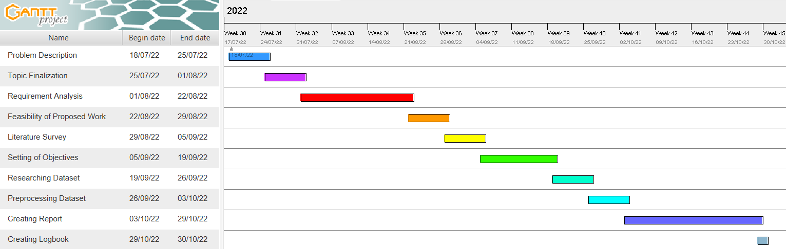
Figure 4.1: Gantt Chart

Chapter 5

Proposed System

5.1. Details of Hardware and Software
- OS: Windows 7 and above operating system
- RAM: 8 GB and above
- Storage Required: 1 GB
- Processor: Intel i5 or Ryzen 5 and higher
- GPU: Recommended
- Internet Connectivity (if using colab)
5.2. Methodology
5.2.1 Dataset - Cifar10 Images
The 60000 32x32 color images in 10 classes—6000 images per class—make up the CIFAR-10 dataset. 10000 test photos and 50,000 training images are available. Five training batches and one test batch, each with 10,000 photos, make up the dataset. Exact 1000 randomly chosen photos from each class make up the test batch. The remaining images are distributed across the training batches in random order, however certain training batches can have a disproportionate number of images from a particular class. The training batches consist of exactly 5000 photos from each class. The classes are completely mutually exclusive. There is no crossover between automobiles and trucks. Automobiles such as cars, SUVs, and similar vehicles are included. Only large trucks are referred to as trucks. None of them contain pickup trucks.

Here are the classes in the dataset, as well as 10 random images from each:
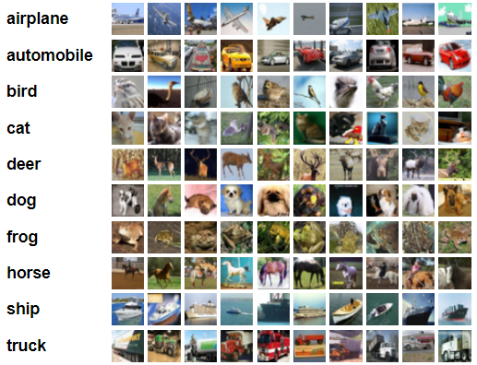
Figure 5.2.1: Cifar10 Dataset
5.2.2 Hyperspectral Images
As is common knowledge, the different hues of red, green, and blue are caused by the reflected light from objects falling within different wavelength ranges of the visible spectrum of electromagnetic radiation [long wavelengths, peaking near 564-580 nm (red), medium-wavelength, peaking near 534-545 nm (green), and short wavelength, peaking near 420-440 nm (blue)]. The visible spectrum only covers a small portion of the wavelengths that can be seen by human eyes, and many of these wavelengths are easily overlooked or invisible to them. As they say, "Color is in the eyes of the beholder," some colors or details that human eyes miss may be comparatively visible to the sight of other creatures.
Modern imaging technology has made it possible for us to collect and interpret data on wavelengths outside of the visible spectrum. Therefore, spectral imaging is broadly defined as the simultaneous capture of spatial and corresponding spectral information in image space, as well as their combination. It is somewhat comparable to an RGB color picture, but it contains many more channels and is thus difficult to perceive all at once.
Let's assume we have an n-band hyper-spectral image for comprehension reasons. This image has the dimensions n rows* m columns* n bands and is created by stacking n grey-scale photos (each band recording different light intensity data according to their wavelength values).
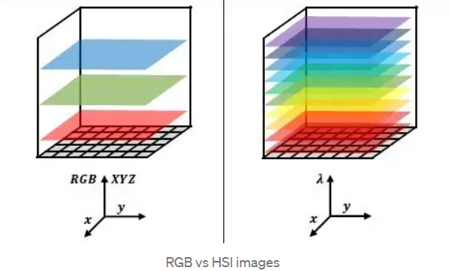
Figure 5.2.2 (a): RGB vs HSI images
Multi-spectral photos, which are essentially n-band images but aren't always dispersed over a continuous wavelength range and contain fewer bands than the usual hyperspectral image, are another option before hyperspectral photographs. The data collected by satellites for remote sensing allows us to view actual multi-spectral photographs.
As a result, any HSI camera will produce an image that is in the shape of a hypercube and contains n-dimensional picture data, which can be difficult to handle at times. As a result, applying dimensional-reduction techniques to the same problem and having a variety of additional ways to treat the hypercube are prevalent. We could plot continuous spectrum data for this hyper-pixel if we tried to concentrate on just one of them.

It has uses in numerous industries, including the automotive industry, agriculture, textiles, and medicine. By visualizing data that is invisible to human eyes and figuring out how to make sense of it, HSI enables us to explore the unexplored.
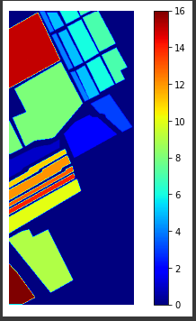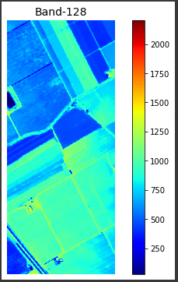
Figure 5.2.2 (b): HSI Ground Truth Figure 5.2.2 (c): HSI Band Sample
High spatial resolution is a feature of the hyperspectral Salinas Scene dataset, which was acquired by the 224-band AVIRIS sensor over the Salinas Valley in California (3.7-meter pixels). The covered region consists of 217 samples along 512 lines. 20 water absorption bands, including [108-112], [154-167], and 224, were discarded. There was just at-sensor radiance data for this photograph. Vegetables, barren soils, and grape fields are all part of it. The ground truth in Salinas has 16 classes.
5.2.3 Few-Shot Learning
sA branch of machine learning which involves categorizing new data when you only have a small number of training samples with supervised data is called few-shot learning. FSL is a very new field that needs more study and development. A computer vision model can perform well even with a small number of training examples. Consider the following scenario: We are in the healthcare industry and are having trouble classifying bone diseases from x-ray images. It's possible that the training set won't have enough photos for some uncommon disorders. This is precisely the kind of issue that an FSL classifier can address. An FSL task's first and most evident phase is to learn from previous, comparable issues. Hence, Few-Shot Learning is classified as a Meta-Learning issue.
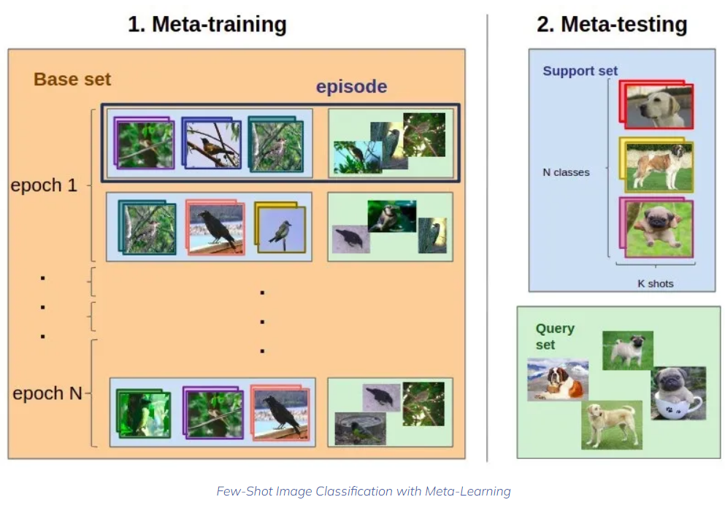
Figure 5.2.3: Few-Shot Image Classification with Meta Learning
An N-way K-Shot classification issue shall be defined. Consider the following:
- A training (support) set that consists of:
  - N class labels
  - K labeled images for each class (a small amount, less than ten samples per class)
- Q query images
We want to classify Q query images among the N classes. The N * K samples in the training set are the only examples that we have. The main problem here is not enough training data.

5.2.4 Resnet18
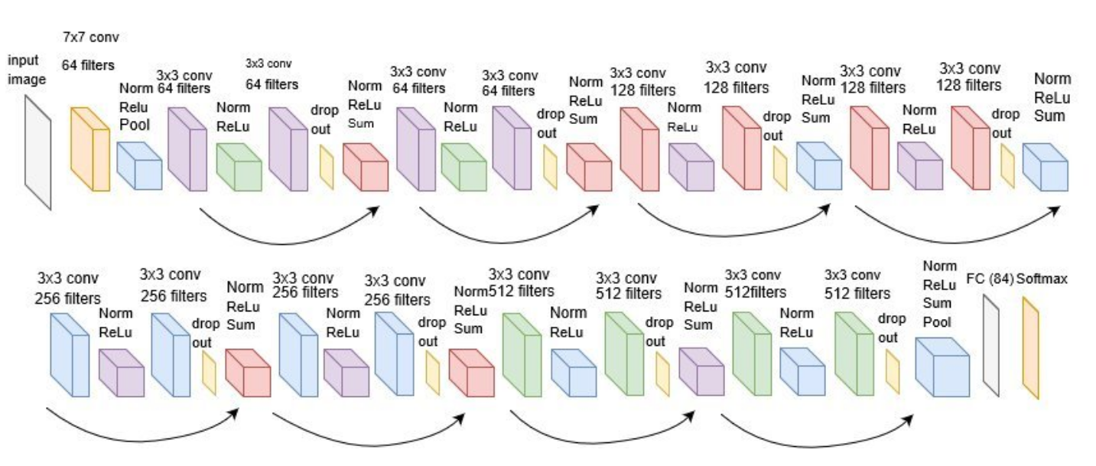
Figure 5.2.4: ResNet18 Architecture with Softmax
A convolutional neural network with 18 layers is called ResNet-18. The ImageNet database contains a pre-trained version of the network that has been trained on more than a million images. The pre-trained network can categorize photos into 1000 different object categories, including several animals, a keyboard, a mouse, and a pencil. The network has therefore acquired rich feature representations for a variety of images. The network accepts images with a resolution of 224 by 224.
5.2.5 Prototypical Networks
In Prototypical Network we continue to employ the same fundamental training approach as usual networks. An episode from the training set is sampled during training. To extract features, the encoder is fed both support set samples and query set samples. We utilize the mean of the generated embeddings for support samples belonging to each class as the representation of the class when K > 1. Bregman divergences or squared Euclidean distance are used to calculate how similar the query photos and each class representation are to one another. Cluster representatives becoming clusters means producing the smallest distance using Bregman divergences. The class of the query image is predicted by using softmax on the negative of these distances.

SoftMax Formula:
$L=-\sum_{i=1}^{n}{log⁡\left(f\left(x_{i}\right)\right)}$

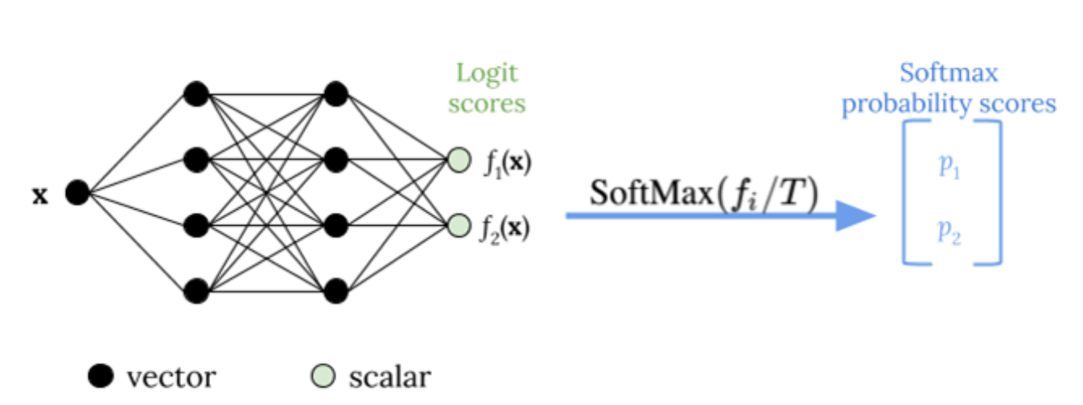
Figure 5.2.5: SoftMax Activation Function
In the case of prototype networks, encoding the episode once using stochastic gradient descent (SGD) does not fully extract the spectral-spatial distribution of HSI data. In order to achieve stability, the confidence interval is reduced by reducing the prediction variance for the true class. We may calculate the overall CE loss for an episode by summing the CE losses for various passes. For each query sample, the standard deviation of multiple prediction probabilities for the correct class is determined. This helps reduce model uncertainty by being added to the overall CE loss after weighting with a constant. Each episode's loss is optimized. The same learning technique is used to the fine-tuning set during fine-tuning.

Chapter 6

Implementation plan for the next semester

Implementation | Timeline | Milestone
Implementation of Temperature Scaling on HSI images | December 2022 | Develop a prototypical network model based on few shot learning with softmax temperature scaling.
Table 2: Implementation Plan for the next semester

Chapter 7

Summary

We suggested a brand-new technique to boost model confidence in FSL. In order to help the model, develop reliable representations for efficient classification, we implemented Temperature Scaling into the encoder and decreased prediction variance by repeatedly running the samples through the encoder. Prototypical Network increases the model's confidence in predicting classes with extremely few spectral-spatial data by minimizing variance loss together with CE loss. Any few-shot-based technique can be stabilized by incorporating the suggested strategy. A prototypical Network improves the existing state-of-the-art (SOTA) FSL approaches for HSI classification by making full use of the parameter space to create stable class prototypes.

Chapter 8

References

[1] Debabrata Pal, Valay Bundele, Biplab Banerjee, and Yogananda Jeppu, SPN: Stable Prototypical Network for Few-Shot Learning-Based Hyperspectral Image Classification, IEEE Geoscience and remote sensing letters, VOL. 19, June 2021
[2] Byung Soo Ko, Han-Gyu Kim, Kyo-Joong Oh & Ho-Jin Choi, “Controlled Dropout: a Different Approach to Using Dropout on Deep Neural Network”, March 2017.
[3] Jake Snell, Kevin Swersky, and Richard Zemel, "Prototypical Networks for Few-shot Learning".
[4] Y. Fang et al., “Dimensionality reduction of hyperspectral images based on robust spatial information using locally linear embedding,” IEEE Geosci. Remote Sens. Lett., vol. 11, no. 10, pp. 1712–1716, Oct. 2014.
[5] C. Rodarmel and J. Shan, “Principal component analysis for hyperspectral image classification,” Surv. Land Inf. Syst., vol. 62, no. 2, pp. 115–122, Jun. 2002.
[6] B. Tu, C. Zhou, X. Liao, G. Zhang, and Y. Peng, “Spectral–spatial hyperspectral classification via structural-kernel collaborative representation,” IEEE Geosci. Remote Sens. Lett., vol. 18, no. 5, pp. 861–865, May 2021.
[7] A. Sellami, A. B. Abbes, V. Barra, and I. R. Farah, “Fused 3-D spectral– spatial deep neural networks and spectral clustering for hyperspectral image classification,” Pattern Recognit. Lett., vol. 138, pp. 594–600, Oct. 2020.
[8] Y. Chen, Z. Lin, X. Zhao, G. Wang, and Y. Gu, “Deep learning-based classification of hyperspectral data,” IEEE J. Sel. Topics Appl. Earth Observ. Remote Sens., vol. 7, no. 6, pp. 2094–2107, June. 2014.
[9] C.-I. Chang, Q. Du, T.-L. Sun, and M. L. G. Althouse, “A joint band prioritization and band-decorrelation approach to band selection for hyperspectral image classification,” IEEE Trans. Geosci. Remote Sens., vol. 37, no. 6, pp. 2631–2641, Nov. 1999.
[10] W. Li and Q. Du, “Gabor-filtering-based nearest regularized subspace for hyperspectral image classification,” IEEE J. Sel. Topics Appl. Earth Observ. Remote Sens., vol. 7, no. 4, pp. 1012–1022, Apr. 2014.
[11] P. Ghamisi, M. D. Mura, and J. A. Benediktsson, “A survey on spectral– spatial classification techniques based on attribute profiles,” IEEE Trans. Geosci. Remote Sens., vol. 53, no. 5, pp. 2335–2353, May 2015.

